LIBRARY CATALOG
@CREATIVITY THINK (9483175986/7019689991)

ABSTRACT:
The Library Catalog is a web-based system designed to streamline the process of book exploration, search, and catalog management for educational institutes, bookstores, and research centers. Users can browse books, filter using advanced search criteria, view detailed information about authors and publishers, and engage through reviews and ratings. Administrators manage book and author data, moderate community reviews, and utilize analytics dashboards for insights. Built using Django and Django Rest Framework for backend operations and React with Data-Grid for an interactive frontend, the system offers an efficient, scalable, and user-friendly digital catalog experience..

INTRODUCTION OF THE PROJECT:
Libraries and bookstores increasingly rely on digital systems to manage their collections and provide users with efficient search and browsing capabilities. The Library Catalog system addresses this need by offering users a dynamic interface for discovering books, authors, and related information while enabling administrators to maintain catalog accuracy and content quality. The system integrates reviews, ratings, and analytics to enhance user engagement and decision-making. Leveraging Django for backend management and React for responsive UI rendering, it ensures secure, smooth, and optimized performance across devices, making book discovery and catalog maintenance significantly more efficient..

PROJECT OBJECTIVES:

• To design a centralized platform for exploring books and authors
• To provide advanced search and filtering options for users
• To enable users to view book details, reviews, and ratings
• To allow administrators to manage book and author information
• To integrate analytics features for catalog usage insights
• To support community engagement through reviews and ratings
• To ensure an efficient and scalable catalog management system

PROBLEM OF THE STATEMENT:
Traditional library catalogs often lack intuitive search features, user engagement tools, and efficient catalog maintenance workflows. Users experience difficulty locating relevant books due to limited filtering options or outdated interfaces. Administrators struggle to maintain accurate book and author information and moderate user-generated content efficiently. The Library Catalog project addresses these shortcomings by offering advanced filtering, structured catalog organization, user reviews, administrator dashboards, and analytics tools to enhance discoverability and streamline catalog management for institutions and users alike..

MOTIVATION OF THE PROJECT:
• Growing demand for digital library and bookstore systems
• Need for improved book search and filtering tools
• Increasing importance of user engagement through reviews
• Need for centralized catalog management with analytics
• Support for educational and research institutions

BLOCK DAIGRAM OF PROJECT:

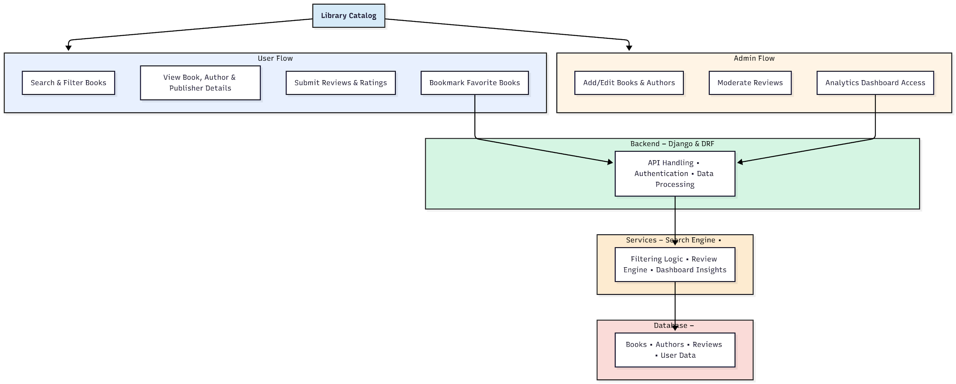

WORKING OF THE PROJECT:
The Library Catalog system begins with users accessing the website to browse, search, and filter through a curated list of books. Users view detailed information on books, authors, and publishers, leave reviews and ratings, and bookmark favorites. The backend handles all API requests, authentication, and catalog operations, while services perform filtering, review management, and analytics processing. Administrators maintain book and author entries, moderate reviews, and analyze usage trends through dashboards. The integrated system ensures seamless discovery, systematic catalog management, and an engaging user experience..

SOFTWARE REQUIREMENT:
- Backend:
  - Python 3.x
  - Django
  - Django REST Framework
  - SQLite/PostgreSQL
- Frontend:
  - Node.js and npm
  - React.js
  - Axios
- Development Tools:
  - Visual Studio Code
  - Postman (for testing APIs)
  - Git/GitHub (for version control)
- Server/Deployment (Optional):
  - Gunicorn, Nginx, or Heroku/AWS for hosting

ADVANTAGES OF THE PROJECT:

• Advanced search and filtering for effective book discovery
• Centralized catalog with structured book and author details
• User engagement through reviews and ratings
• Efficient catalog handling for administrators
• Analytics dashboards to understand user behavior
• Improved accessibility and discoverability of books
• Scalable system suitable for institutions and bookstores
• Modern UI for enhanced user convenience

APPLICATIONS OF THE PROJECT:
• School and university libraries
• Public and community libraries
• Online bookstore catalog systems
• Research institutes and archives
• Corporate knowledge centers
• Digital learning platforms
• Private book collections
• Literary and academic organizations

REFERENCES:

- Django REST Framework Documentation — Django Software Foundation. Django Documentation. Available: https://docs.djangoproject.com/
- Django REST Framework. DRF Documentation. Available: https://www.django-rest-framework.org/
- React. React Official Documentation. Available: https://reactjs.org/docs/getting-started.html
- Redux. Redux Documentation. Available: https://redux.js.org/introduction/getting-started
- PostgreSQL Global Development Group. PostgreSQL Documentation. Available: https://www.postgresql.org/docs/
- MySQL. MySQL Reference Manual. Available: https://dev.mysql.com/doc/
- Git. Git Documentation. Available: https://git-scm.com/doc
- Node.js. Node.js Documentation. Available: https://nodejs.org/en/docs/
- Axios. Axios Documentation. Available: https://axios-http.com/docs/intro
- Socket.io Documentation – https://socket.io/docs/

